Code:

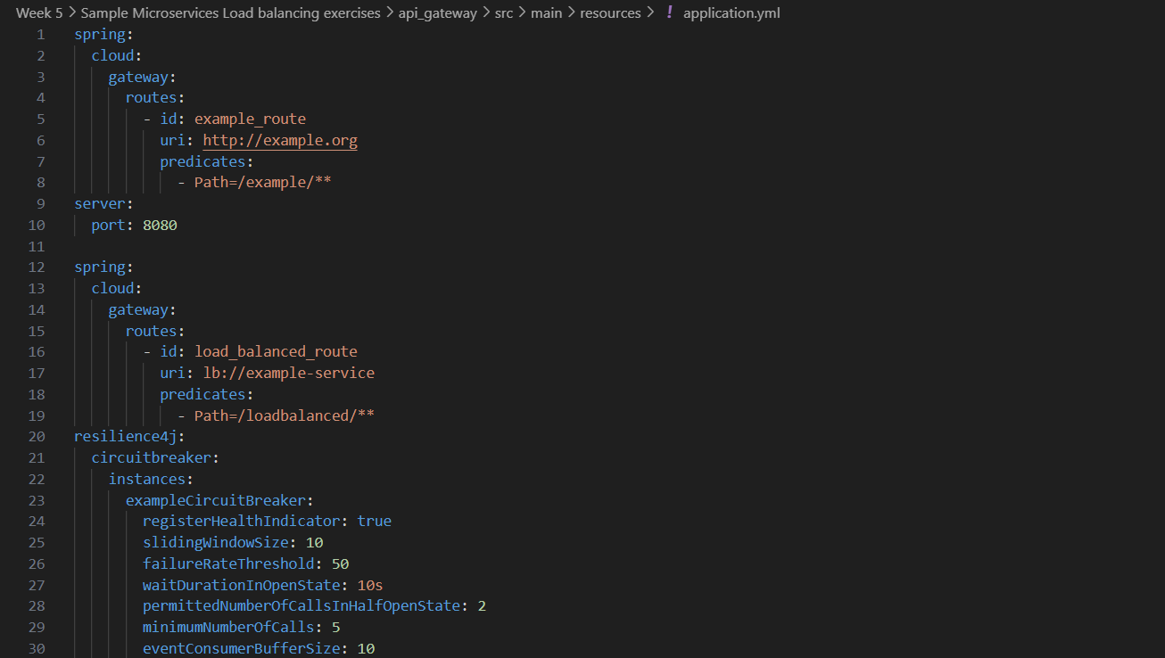application.yml

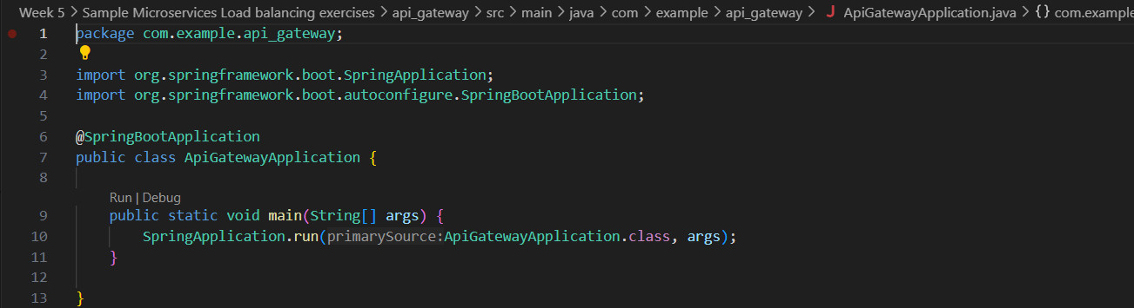ApiGatewayApplication.java

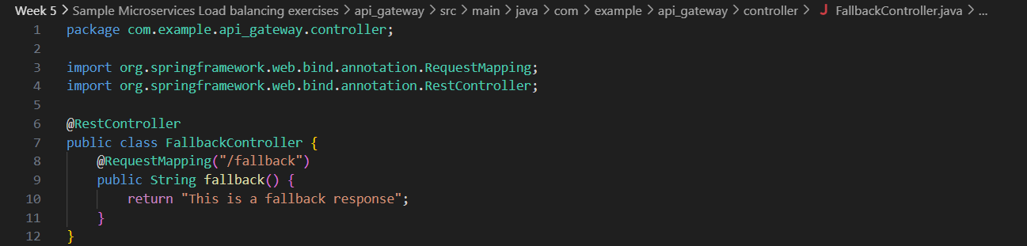FallbackController.java

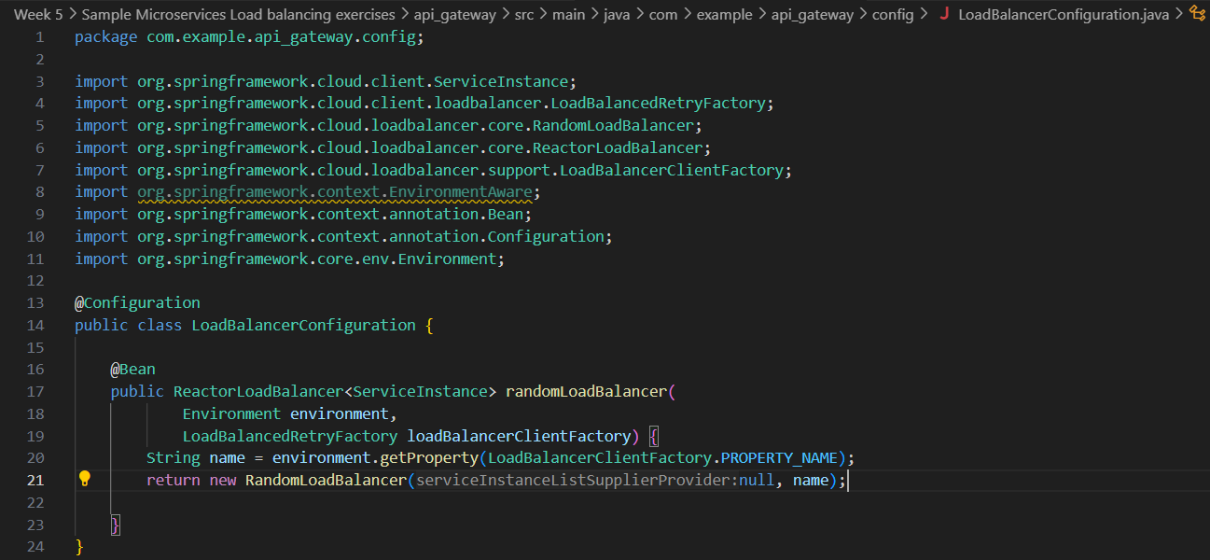LoadBalancerConfiguration.java

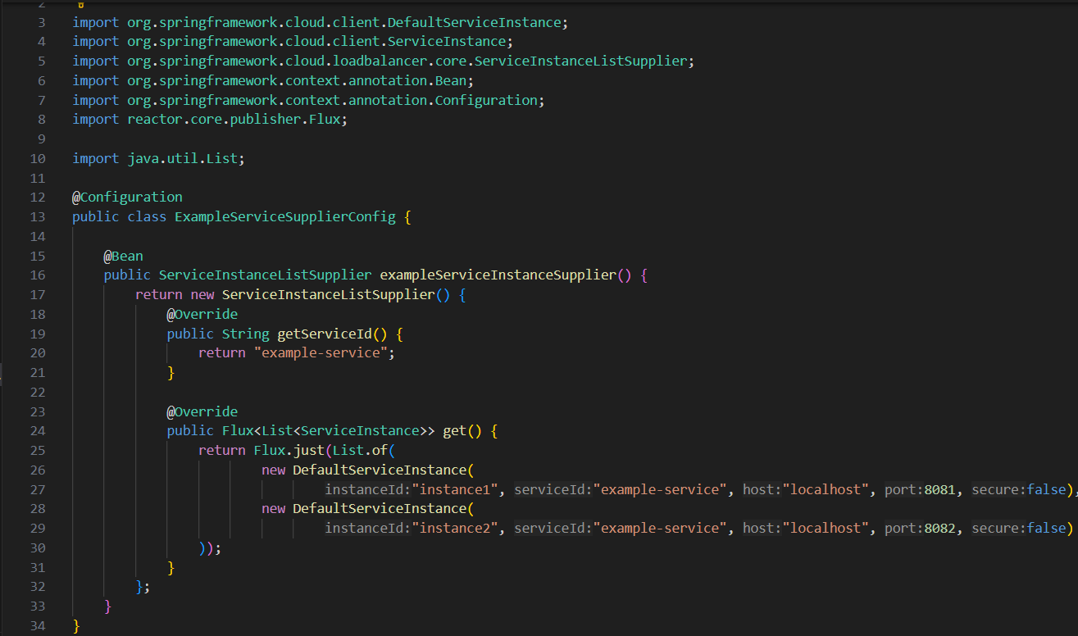ExampleServiceSupplierConfig.java